[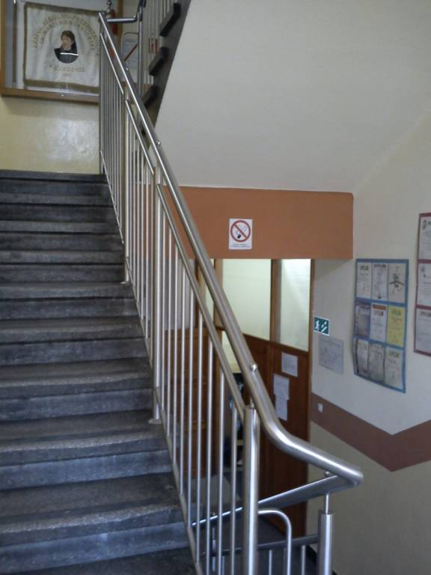](http://wolmar.pl/images/gallery/40/1a9npk.jpg)

1

[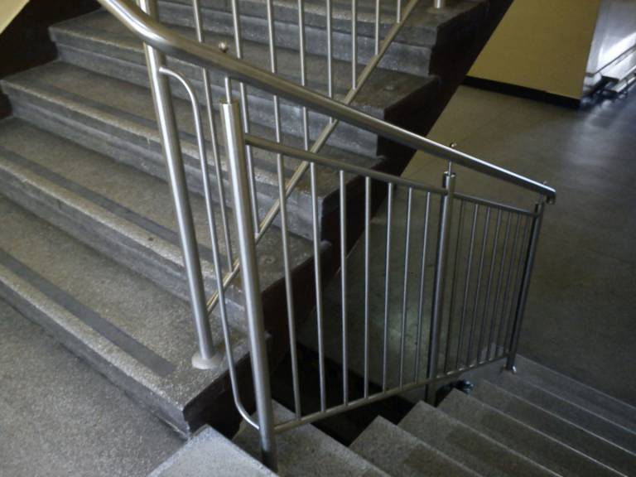](http://wolmar.pl/images/gallery/40/2nj6su.jpg)

2

[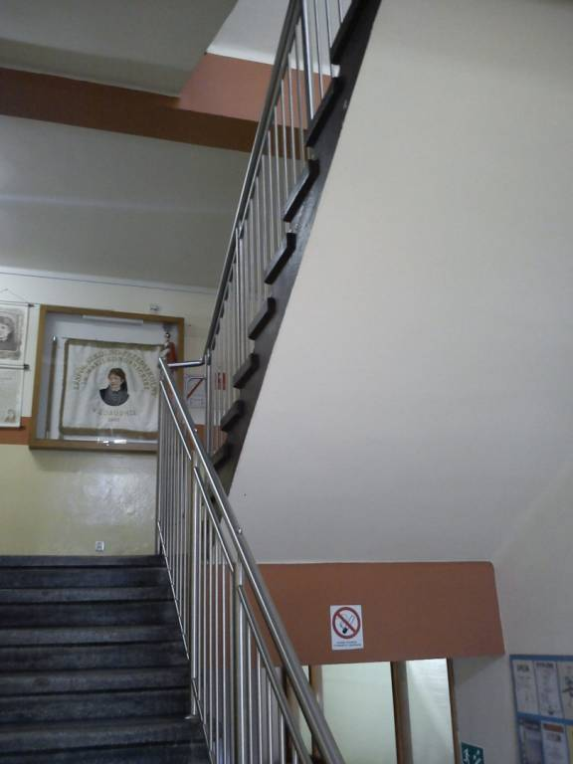](http://wolmar.pl/images/gallery/40/3j0krt.jpg)

3

[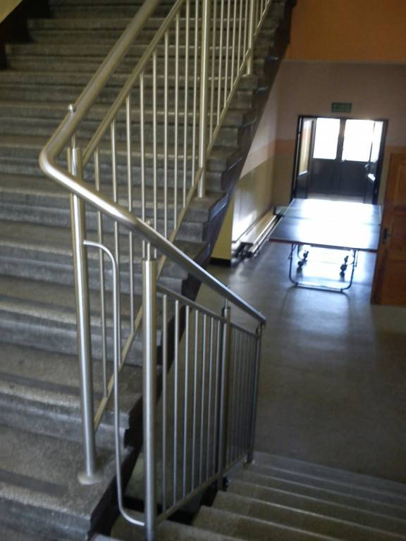](http://wolmar.pl/images/gallery/40/1-2ih3mc.jpg)

4

* BALUSTRADY
  + [ZE STALI NIERDZEWNEJ](http://wolmar.pl/balustrady-ze-stali-nierdzewnej)

